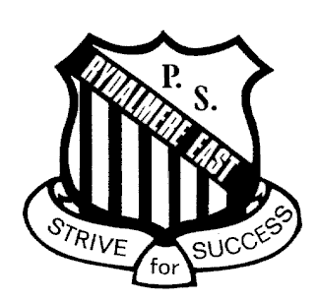
RYDALMERE EAST PUBLIC SCHOOL

Spurway St, Ermington 2115
Phone: 9638-2250

Fax: 9638-0191
rydalmeree-p.school@det.nsw.edu.au
www.rydalmeree-p.schools.nsw.edu.au

2014 International Competitions and Assessments for Schools (ICAS)

Registration Form

Please return this form to your child’s school

I give permission for my child of
Child’s name Class

to participate in the following 2014 International Competitions and Assessments for Schools (ICAS):

Please select the subjects you would like your child to enter:

Subject/Paper | School Years | Official Sitting Date | Entry fee, incl. GST | Fee enclosed
Computer Skills | 3 – 10 | 20 May 2014 | $8.80
Science | 2 – 12 | 4 June 2014 | $8.80
Writing | 3 – 12 | 16-20 June 2014* | $18.70
Spelling | 3 – 7 | 17 June 2014 | $12.10
English | 2 – 12 | 29 July 2014 | $8.80
Mathematics | 2 – 12 | 12 August 2014 | $8.80
 |  |  | TOTAL

Please find enclosed ____________________total entry fee.
Amount

Name of Parent/Guardian Date

________________________________________________________________________
Signature of Parent/Guardian

